
Total: 80
Weighting 2.5%
Year 11 ATAR Geography
Task 10A - Fieldwork Booklet
Unit 2 – Global Networks and Interconnections
Depth Study Two – Tourism

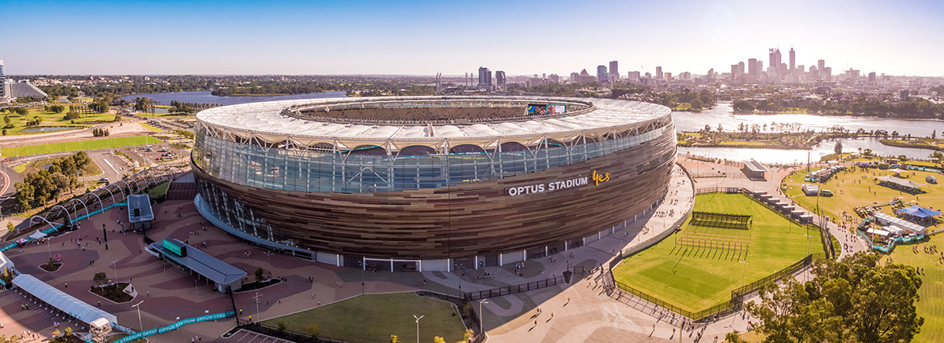

Name: _________________________________________
Date: __________________________________________

Background: Tourism in Perth
- Define Tourism. (2 marks)

______________________________________________________________________________________________________________________________________________________________________________
Scan the QR code. Read the source and complete the following questions.
- Using the source, describe reasons why Perth, Australia is a tourism destination. (3 marks)
______________________________________________________________
______________________________________________________________
______________________________________________________________
______________________________________________________________________________________________________________________________________________________________________________
- Click on “Things to Do in Perth” and list the top 5 attractions in Perth. (5 marks)

- ________________________________________________________________
- ________________________________________________________________
- ________________________________________________________________
- ________________________________________________________________
- ________________________________________________________________
Site One: Optus Stadium

Use field observations and measurements complete the following activities. Note* you may complete this before or after the tour.
Go to Gate D.

Complete the following to collect data regarding the SITUATION of Optus Stadium.
- Using Google maps, measure and state the straight-line distance between Optus Stadium and the Point Zero Marker for Perth. (1 mark)
________________________________________________________________________

- State the direction of Optus Stadium from the point Zero Marker for Perth. (1 mark)
________________________________________________________________________
- Using Google maps, determine the latitude and longitude of Optus Stadium. (1 mark)

___________________________________________________________________________

- Scan the QR code. Determine the approximate range in height above sea level and topography for Optus Stadium by using the interactive topographic map. (2 marks)
_____________________________________________________________
_____________________________________________________________

- Observe the area around you and make observations about the natural features (hydrological/vegetation). (2 marks)

_____________________________________________________________
_____________________________________________________________
- Using the information, you have collected, outline two Site and Situation features/characteristics of Optus Stadium. (4 marks)

Site
- ____________________________________________________________________________________________________________________________________________________________________________________________________________________________________________________________________________________________________________________________________________________

- ____________________________________________________________________________________________________________________________________________________________________________________________________________________________________________________________________________________________________________________________________________________

Situation
- ____________________________________________________________________________________________________________________________________________________________________________________________________________________________________________________________________________________________________________________________________________________

- ____________________________________________________________________________________________________________________________________________________________________________________________________________________________________________________________________________________________________________________________________________________

Take a walk around the Optus Stadium Precinct, making observations and collecting primary data to answer the questions below.
- Make a 5 list of features of Optus Stadium that make it a tourism asset. (5 marks)

- _________________________________________________________________________________
- _________________________________________________________________________________
- _________________________________________________________________________________
- _________________________________________________________________________________
- _________________________________________________________________________________
- List 4 transport options used to access Optus Stadium. (4 marks)

- _________________________________________________________________________________
- _________________________________________________________________________________
- _________________________________________________________________________________
- _________________________________________________________________________________
- State an example of an enterprise at Optus Stadium. Outline their role in the internationalisation of the production and consumption of tourism. (Hint: How do they contribute to tourism?) (3 marks)
_________________________________________________________________________________________________________________________________________________________________________________________________________________________________________________________________________________________________________________________________________________________________________________________________________________________________________________________________________________________________________________________________________________________________________________________________________________________________
- Make a list of 5 facilities that are present at Optus Stadium that contribute to the accessibility as a tourism destination. (5 marks)

- _________________________________________________________________________________
- _________________________________________________________________________________
- _________________________________________________________________________________
- _________________________________________________________________________________
- _________________________________________________________________________________
Use your observations/scan the QR codes to complete the questions below.
- Optus Stadium’s role in the production and consumption of Tourism. Describe how each of the following initiatives will help to increase the production and consumption of tourism in Western Australia. (12 marks)
- Major Events
________________________________________________________________________________________________________________________________________________________________________________________________________________________________________________________________________________________________________________________________________________________________________________________________________________________________________________________________________________________________________________________________________________________________________________________________________________________________________
- Matagarup Bridge
________________________________________________________________________________________________________________________________________________________________________________________________________________________________________________________________________________________________________________________________________________________________________________________________________________________________________________________________________________________________________________________________________________________________________________________________________________________________________
- Outdoor Amphitheatre
________________________________________________________________________________________________________________________________________________________________________________________________________________________________________________________________________________________________________________________________________________________________________________________________________________________________________________________________________________________________________________________________________________________________________________________________________________________________________
- The Ozone
________________________________________________________________________________________________________________________________________________________________________________________________________________________________________________________________________________________________________________________________________________________________________________________________________________________________________________________________________________________________________________________________________________________________________________________________________________________________________
Scan the QR codes below. Read the articles for extra information.

Major Events



Matagarup Bridge



BHP Boardwalk and Outdoor Amphitheatre The Ozone



- Draw a field sketch: Arriving at Gate D looking out over towards the CBD in a westerly direction, complete a quick sketch of the area in front of you. Remember to use pencil and include a title.
(10 marks)

Label the following:
- Swan River
- Central Business District
- BHP Boardwalk
- Matagarup Bridge
- Outdoor Amphitheatre

Hints:
- Only show main features
- Make sure your sketch is clear and easy to read/understand
- Ensure you annotate your sketch
- You may like to use a key to add extra notes and differentiate between features
- You may like to take a photo to help with the completion of your sketch

Fieldwork Sketch
Title: _______________________________________________________________________________ Date: _____________________________________
- Make notes and observations during your tour of Optus Stadium; particularly in relation to tourism in Perth and the role of Optus Stadium. (20 marks)

Name of Tour Guide: ____________________________________________________________________________
Facts about the Stadium as a Venue for Major Events and how this contributes to Tourism. Facts about the Stadium and how it caters for visitors and tourists.
__________________________________________________________________________________________________________________________________________________________________________________________________________________________________________________________________________________________________________________________________________________________________________________________________________________________________________________________________________________________________________________________________________________________________________________________________________________________________________________________________________________________________________________________________________________________________________________________________________________________________________________________________________________________________________________________________________________________________________________________________________________________________________________________________________________________________________________________________________________________________________________________________________________________________________________________________________________________________________________________________________________________________________________________________________________________________________________________________________________________________________________________________________________________________________________________________________________________________________________________________________________________________________________________________________________________________________________________________________________________________________________________________________________________________________________________________________________________________________________________________________________________________________________________________________________________________________________________________________________________________________________________________________________________________________________________________________________________________________________________________________________________________________________________________________________________________________________________________________________________________________________________________________________________________________________________________________________________________________________________________________________________________________________________________________________________________________________________________________________________________________________________________________________________________________________________________________________________________

Extra Space for notes and observations:
____________________________________________________________________________________________________________________________________________________________________________________________________________________________________________________________________________________________________________________________________________________________________________________________________________________________________________________________________________________________________________________________________________________________________________________________________________________________________________________________________________________________________________________________________________________________________________________________________________________________________________________________________________________________________________________________________________________________________________________________________________________________________________________________________________________________________________________________________________________________________________________________________________________________________________________________________________________________________________________________________________________________________________________________________________________________________________________________________________________________________________________________________________________________________________________________________________________________________________________________________________________________________________________________________________________________________________________________________________________________________________________________________________________________________________________________________________________________________________________________________________________________________________________________________________________________________________________________________________________________________________________________________________________________________________________________________________________________________________________________________________________________________________________________________________________________________________________________________________________________________________________________________________________________________________________________________________________________________________________________________________________________________________________________________________________________________________________________________________________________________________________________________________________________________________________________________________________________________________________________________________________________________________________________________________________________________________________________________________________________________________________________________________________________________________________________________________________________________________________________________________________________________________________________________________________________________________________________________________________________________________________________________________________________

